CULSED Software Manual

1. Program requirement

CULSED was originally developed for ArcMap ver. 8.2 and Windows 2000 platforms by Florentiu Damian (Damian, 2003). CULSED software has been updated to ArcMap ver. 9.1 and Windows XP platforms. Please make sure that your computer has ArcMap ver. 9.1 with Spatial Analysis extension.

2. Installation

1) The goal of installation

CULSED is comprised of two ArcMap extensions named

Road Sediment Analyst
RSA Sediment Modeler

Upon successful installation they will show up in the tools->extensions menu item of ArcMap shown below.

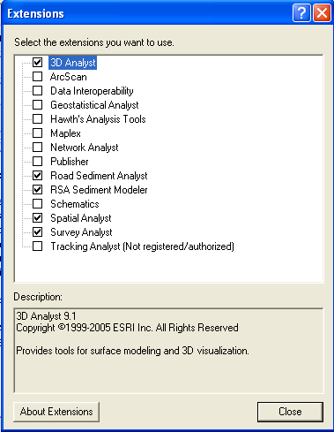

A dedicated toolbar provided with the program will also be found in the ArcMap list of tools.

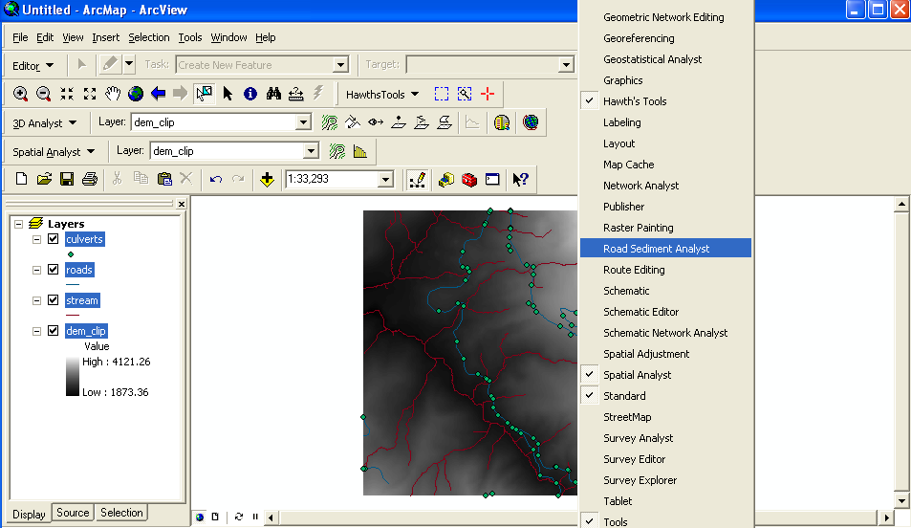

Click Road Sediment Analysis and see the tool bar appeared on ArcMap.

2) Installation Steps

a. Download Setup.Exe and CULSED.msi (Click on these active links, you can go to the site directly) to a permanent directory on your computer. (Please create a folder named “CULSED” in your C drive and save Setup.Exe and CULSED.msi there)

http://faculty.washington.edu/akiran/CULSED/

b. Install CULSED software.
Click CULSED.msi on your directory.

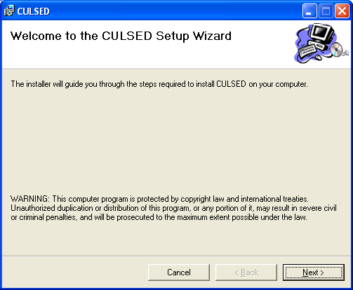

Click Next

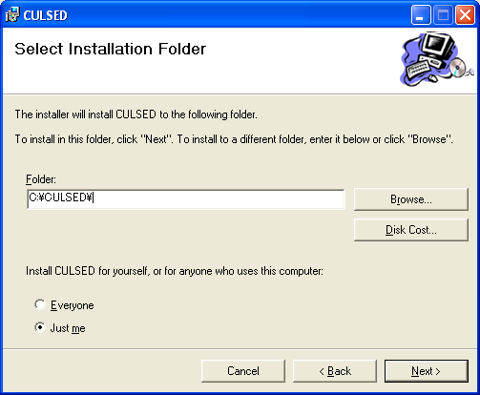

Select the folder named CULSED in your C drive. Click Next and finish this installation.

c. Register RoadSedimentAnalysis.dll
Go to Start -> Run
And copy and paste the line below.

C:\WINDOWS\Microsoft.NET\Framework\v2.0.50727\RegAsm.exe C:\CULSED\RoadSedimentAnalyst.dll

RegAsm.exe registers RoadSedimentAnalyst.dll above.

Special Attention -----------------------------------------------------------------------------------
If your computer doesn’t have any RegAsm.exe, you can’t register this dll. For this case, please download RegAsm.exe from Visual Studio Express Edition below.

http://msdn.microsoft.com/vstudio/express/vb/download/

This is free software. When you download the software, Framework folder is also downloaded. The Framework folder contains RegAsm.exe.
If you register your name to Microsoft, you can start to use this Visual Studio software, but this CULSED software only requires RegAsm.exe. It means that the registration of Visual Studio software is not necessary to use CULSED software.
If you have any questions for this issue, please feel free to contact me (akiran@u.washington.edu)

If you are not sure that you have RegAsm.exe,
Go to Start -> Run
Type

cmd

You can see a black screen. And type (or copy and paste) the line

C:\WINDOWS\Microsoft.NET\Framework\v2.0.50727\RegAsm.exe

If you can’t see any command syntax about RegAsm.exe, you need to get RegAsm.exe

So far I only know RegAsm.exe can be downloaded from Visual Studio Express Edition. However, you may find the other source to get RegAsm.exe by internet.
-----------------------------------------------------------------------------------------------------------

c. Start ArcMap and verify that two extensions were added and the CULSED toolbar is available. If so you are ready to use the program.

How to uninstall CULSED

- Unregister CULSED

Go to Start -> Run -> type “cmd”
Copy and paste the line below on the black window.

C:\WINDOWS\Microsoft.NET\Framework\v2.0.50727\RegAsm.exe /unregister C:\CULSED\RoadSedimentAnalyst.dll

- Uninstall CULSED

Go to Start -> Control Panel -> Add or Remove Programs
Find “CULSED” and remove it.

Note: If you uninstall CULSED without unregister CULSED, ArcGIS may not
start at all from the next use. Please unregister the first and then uninstall CULSED.

3. Data requirement

The CULSED analysis requires the following four dataset.

- Digital Elevation Model (DEM)
This Dataset must be free of sinks and be able to derive a stream layer with the minimum contributing area method.
You can get free DEM from USGS website below.
http://courses.washington.edu/esrm590/lessons/find_data/exercise/index.html#get_dem

- Stream Layer
Linear feature and this dataset must align with the digital elevation model. Optimally this stream layer should be generated from the DEM.
How ?
Please see the tutorial how to make stream from DEM below.
http://courses.washington.edu/esrm590/lessons/hydrology/exercise/index.html#delineation

- Culvert point
Point layer and this dataset could contain existing culvert locations. If there are no existing location the layer is still required and should be empty.

- Road Layer
Linear feature. The road segments should be representative of the changes in sediment producing factors (i.e. grade, width, surface, material, etc.) which are given as attributes. The valid values of these attributes are given in options menu (see below)

As a demonstration of this tutorial, you can download the dataset from the website below.
http://faculty.washington.edu/akiran/CULSED/
Please download the data named Culsed_Data.zip and unzip the file to save the file to the CULSED folder in C drive.

Before you use the software …

Add four layers to ArcMap

DEM named dem_clip
Stream layer named stream.shp.
Culvert point named culvert.shp
Road layer named road.shp

Please check three extensions

Tools -> Extensions

Check

Spatial Analyst
Road Sediment Analyst
RSA Sediment Modeler

3. Software Tutorial

This session presents the tools and menu items present on the CULSED toolbar.

The CULSED toolbar is composed of 9 tools and 6 menu items that operate on existing data and control the flow of the culvert analysis session.

A small window on the toolbar presents the total amount of sediment delivered by the analyzed road network at each step during analysis. The sediment volume is expressed in tons/year.

All CULSED operations must be performed within a analysis session. The session steps must be performed in order. If the session is not completed in one setting the user can leave it open in order to be solved with the ArcMap project. When the session is stopped all progress is cleared and all internal variables reinitialized.

Note: the Spatial Analysis extension must be installed for CULSED to function properly.

- Culvert Spacer -> Start

This item starts an alaysis session. The user is prompted to provide the needed analysis layer shown in below.

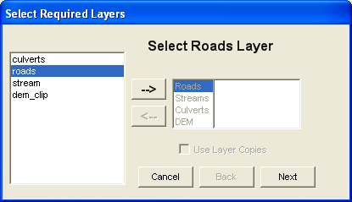
Click 1
Click 2
Click 3

CULSED requires the following layers: DEM, a road layer, a culvert point layer, and a stream layer. Please define each layer here as the input of this software.

Note: for the best results a DEM must be free of sinks and the stream layer must align with it. One convenient method for generating streams from a DEM is the minimum contributing area method.

- Culvert Spacer -> Road Setup
This menu item runs a series of algorithms that setup the road network from a geometric perspective. A road grade is estimated and stored in the road attribute table.

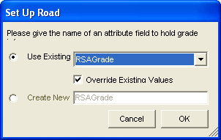

If you have already created RSAGrade field, please select from the top down menu. If you haven’t, please check the bottom and create new RSAGrade field. Then click OK.

CULSED assumed that each road segment presents a consistent combination of sediment production factors (e.g. road grade, road width, surface material etc). At this stage in the analysis the user must examine the road segments and ensure that this condition is met. Because the road grade is estimated from a DEM it may not necessarily reflect the actual road reality. CULSED provides tools for splitting and merging road segments, changing flow direction and modifying grade.

Note: to properly estimate the road grade the vertical units of the DEM must be the same with the horizontal units. If they differ the user must correct the grade values in the attribute table appropriately.

Editing the grade and road segments
The items are activated after the road setup are used to edit the grade and road segments. Each item is explained below.

SegmentGrade

This tool changes the grade of a road segment. Click on a segment to display grade. Type a new value and right click to commit the change.

NodeGrade

This tool simultaneously changes the grade of all road segments at a certain intersection. Left click to increase grade. Right click to decrease grade.

Flip

This tool changes the flow direction along a road segment. The flow direction along the side ditch is represented with arrows. Use this tool when the DEM estimated grade is incorrect.

Split

This tool splits a road segment in two parts. All attributes are copied onto the newly created segments.

Merge

This tool merges two roads into one. The road grade is taken from one of the segments. When more than two segments meet at an intersection click the intersection with the left button and while keeping the button depressed press the right button to select which segments will get merged.

EnforCon

This command enforces geometric consistency, eliminating duplicate segments, and forcing node connectivity (simplifies geometries) to ensure proper topology. Make sure to use this command when you are done with all edits and are ready to proceed to next step.

- Culvert Spacer -> Flow SetUp
This menu items runs a series of algorithms that construct the internal logical network and establish how water flows along the side ditch. The road segments are identified as parents and children based on their physical connectivity. All existing culverts are snapped to the road lines and new culverts are placed at stream crossings.

In certain cases, the network topology algorithms cannot automatically identify the parent-child relationships needed for modeling the water travel. A list of those cases is presented to user during flow setup. The user must click on each item on the list and using the ArcMap selection tool direct the water on its way to the next ditch segment.

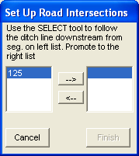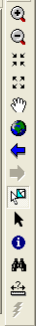
Click 1
Click 2

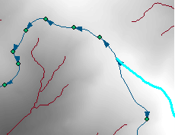
Click 3 (Select and click one of them)

And

Then click Finish
Click 4

Note: some culverts are not snapped, if they are located away from the road. Snap works within 100 feet buffer from the road line. If the culverts, which are not snapped during this setup, exit, their ID numbers are appeared at the end of this process. If you want to include those culverts, you have to add them manually during the analysis time.

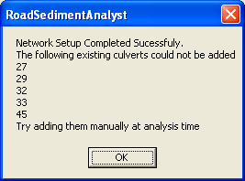

- Culvert Spacer -> Analyze Sed
This menu item runs the sediment modeling algorithms that associate a sediment production to each road segment and determine the flow path distance from each potential culvert location to the nearest stream. This module works in conjunction with the spatial analyst extension to perform raster calculations and attribute modifications. The sediment model is implemented as a separate extension in order to provide interchangeability at run time. The options menu specifies which available sediment model is currently used.

The default sediment model provided with this version of CULSED follows the procedures in the WA DNR Manual for Conducting Watershed Analysis. The following sediment production parameters can be specified as road attributes and are associated to each segment: age, grade, width, surface material traffic, and side slope cover. Other parameters such as precipitation and parent material are considered uniform over the entire study area. If no attributes tables are specified, a set of default road characteristic arc applied. They can be viewed and modified in the option menu.

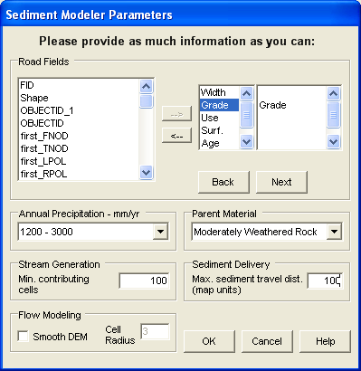

Please set the parameters as they are shown above. And click OK.

A minimum number of contributing cells is required for computing the flow paths to the nearest streams. A raster layer of streams is generated during this process. For accurate results this number should produce a stream layer identical to the one used in the input section.

The flow modeling section is useful when working with high resolution elevation models. A typical problem when modeling water flow in these cases is the stream capture by the road ditch. To reduce the stream capturing effects the elevation models can be smoothed with a circular neighborhood of given radius.

The maximum sediment travel distance represents is a generic number that influences the sediment deposition factor used for calculating a probability of sediment delivery. This number is particular to local conditions and should be based on empirical observations at the site. The user’s expertise is important for obtaining valid results.

Culvert Operation Tools

A set of tools that allow insertion, relocation and removal of cross drain culvert is provided. These tools only become available after the sediment analysis has been performed. Operating any of these tools triggers recalculations of sediment delivery probability and summation of total sediment delivered by the road network. These changes are reflected in the sediment window.

AddCulv

This tool inserts a new cross drain in the road drainage system.

MoveCulv

This tool moves a cross drain culvert to a different location.

Remove Culvert

This tool removes a cross drain from the road drainage system.

- Culvert Spacer -> Stop
Stop an analysis session and clears all variable. Use only when a session is completed.

- Culvert Spacer -> Options
The operations menu presents specifies the sediment model to be used and give the default road characteristics for sediment production calculations.

A new ArcMap extension must be developed in order to use a different sediment model. This extension must be written in Visual Basic and must implement the IsedimentModel interface provided with the CULSED code (Damian, 2003). This interface specifies the methods necessary for CULSED to be able to integrate with a sediment model.

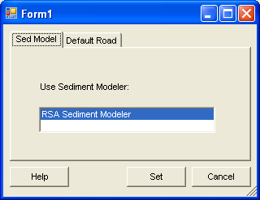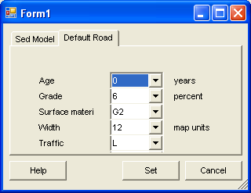

Once the sediment analysis has been run, an amount of sediment delivered will be associated to each existing culvert.

Result

To take advantage of the intended graphic comparison the amount of sediment must be drawn with proportional symbols based on the filed called “SED” in the culvert layer’s attribute table.

How
Go to layer’s properties

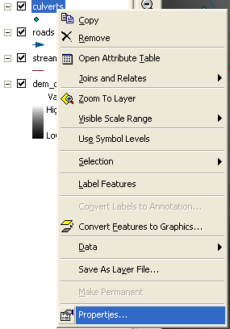
Click 1

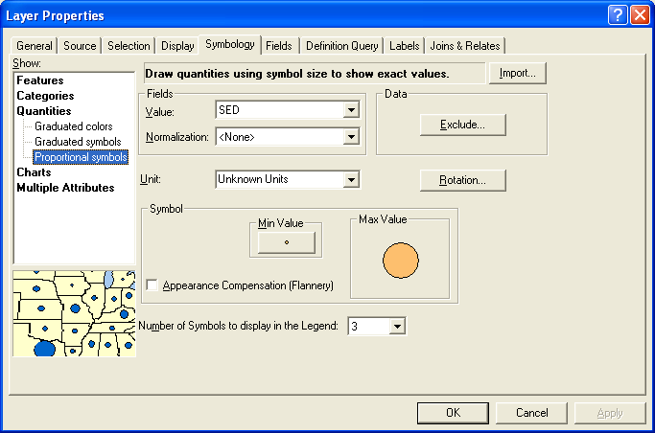
Click 2
Select SED (Click 3)
Click 4

You can change the color of circles at Click 4

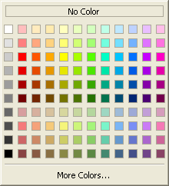
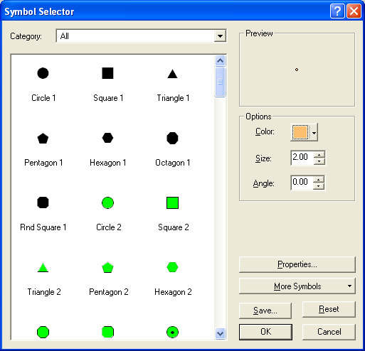
Click 5

If these values are spread over a wide range it is helpful to “stratify” the analysis and start by representing the big contributors. As sedimentation is reduced by moving culverts to different locations, the culverts in the lower sediment ranges can also be included. Most of the sedimentation will be located near the stream crossings and it is these locations where users can make the greatest improvements to their drainage systems. The optimum location will be the place where all culverts can have equally small sediment contribution. The result of the sample data is shown below.

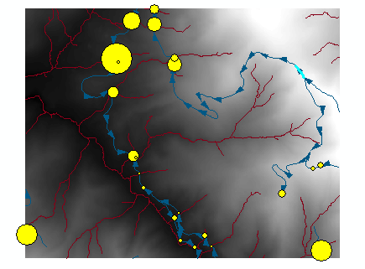

As the demonstration of the change of sediment in terms of moving culverts, the effect is shown below.

Before moving a culvert After moving a culvert

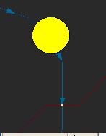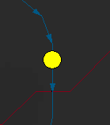

Move

Reference

Damian, Florentiu “Cross-drain Placement to Reduce Sediment Delivery from Forest Roads to Streams, 2003.
http://www.ruraltech.org/pubs/theses/damian/damian_ms_thesis.pdf

Software Update log
Sept.2006
Akira Kato, Luke Rogers, Peter Schiess.
Updated CULSED for the version from ArcGIS 8.2 and ArcVB 6 to ArcGIS 9.1 and VB .NET 2003.

